**Methods**

In order to check for selective reporting and make sure that what we are observing is not simply the result of publication bias and p-hacking, we carried out *p*-curve analyses based on Simonsohn, Nelso, and Simmons (2014). According to Simonsohn et al. (2014), a *p*-curve presents visually the distribution of the *p* values that are statistically significant for a set of studies (*p*s <. 05), and when the effect truly exists, for example, if we set the significance level to 0.05, then we should expect to see more low *p* values (0.1s) than *p* values that although are smaller than 0.05, but very close to it (0.04s).Therefore, we can conclude that there is no need to worry about publication bias only when the *p*-curve is right-skewed, indicating a majority of low *p*s in the set of studies that are included in our meta-analysis.

The *p*-curve analysis was conducted not only for effect sizes of all the studies that are in our meta-analysis, but was also carried out separately for the agentic and communal constructs. This is inspired by one of the reviewers, who has proposed that it is possible that publication bias may be observed for the agentic constructs, in that they are the focal constructs in most published studies on narcissistic self-enhancement.

The *p*-curve analyses were realized via the online APP 3.0 (<http://www.p-curve.com/app3/>) developed by Simonsohn, Nelson, and Simmons.

**Results:**

177 effect sizes were entered to the online APP along with the sample size. For example, the first result entered comes from a study with a sample size of 145, and the effect size, which is the correlation between narcissism and self-enhancement, equals 0.13. Therefore, we entered r(145) = .13 in the box on the APP website, along with all other 176 results in the same format.

Out of the 177 effect sizes, 71 of them were excluded from *p*-curve because they were not statistically significant at the significance level of 0.05. The remaining 106 significant results were included in the *p*-curve.

In Figure 1 the distribution of the *p* values of all significant results are demonstrated, presenting a curve of *p* values that is statistically significantly right-skewed. Therefore, we can conclude that there is indeed evidential value in the set of studies that are included in our meta-analysis, and the effect sizes we have are not the results of publication bias or selective reporting.

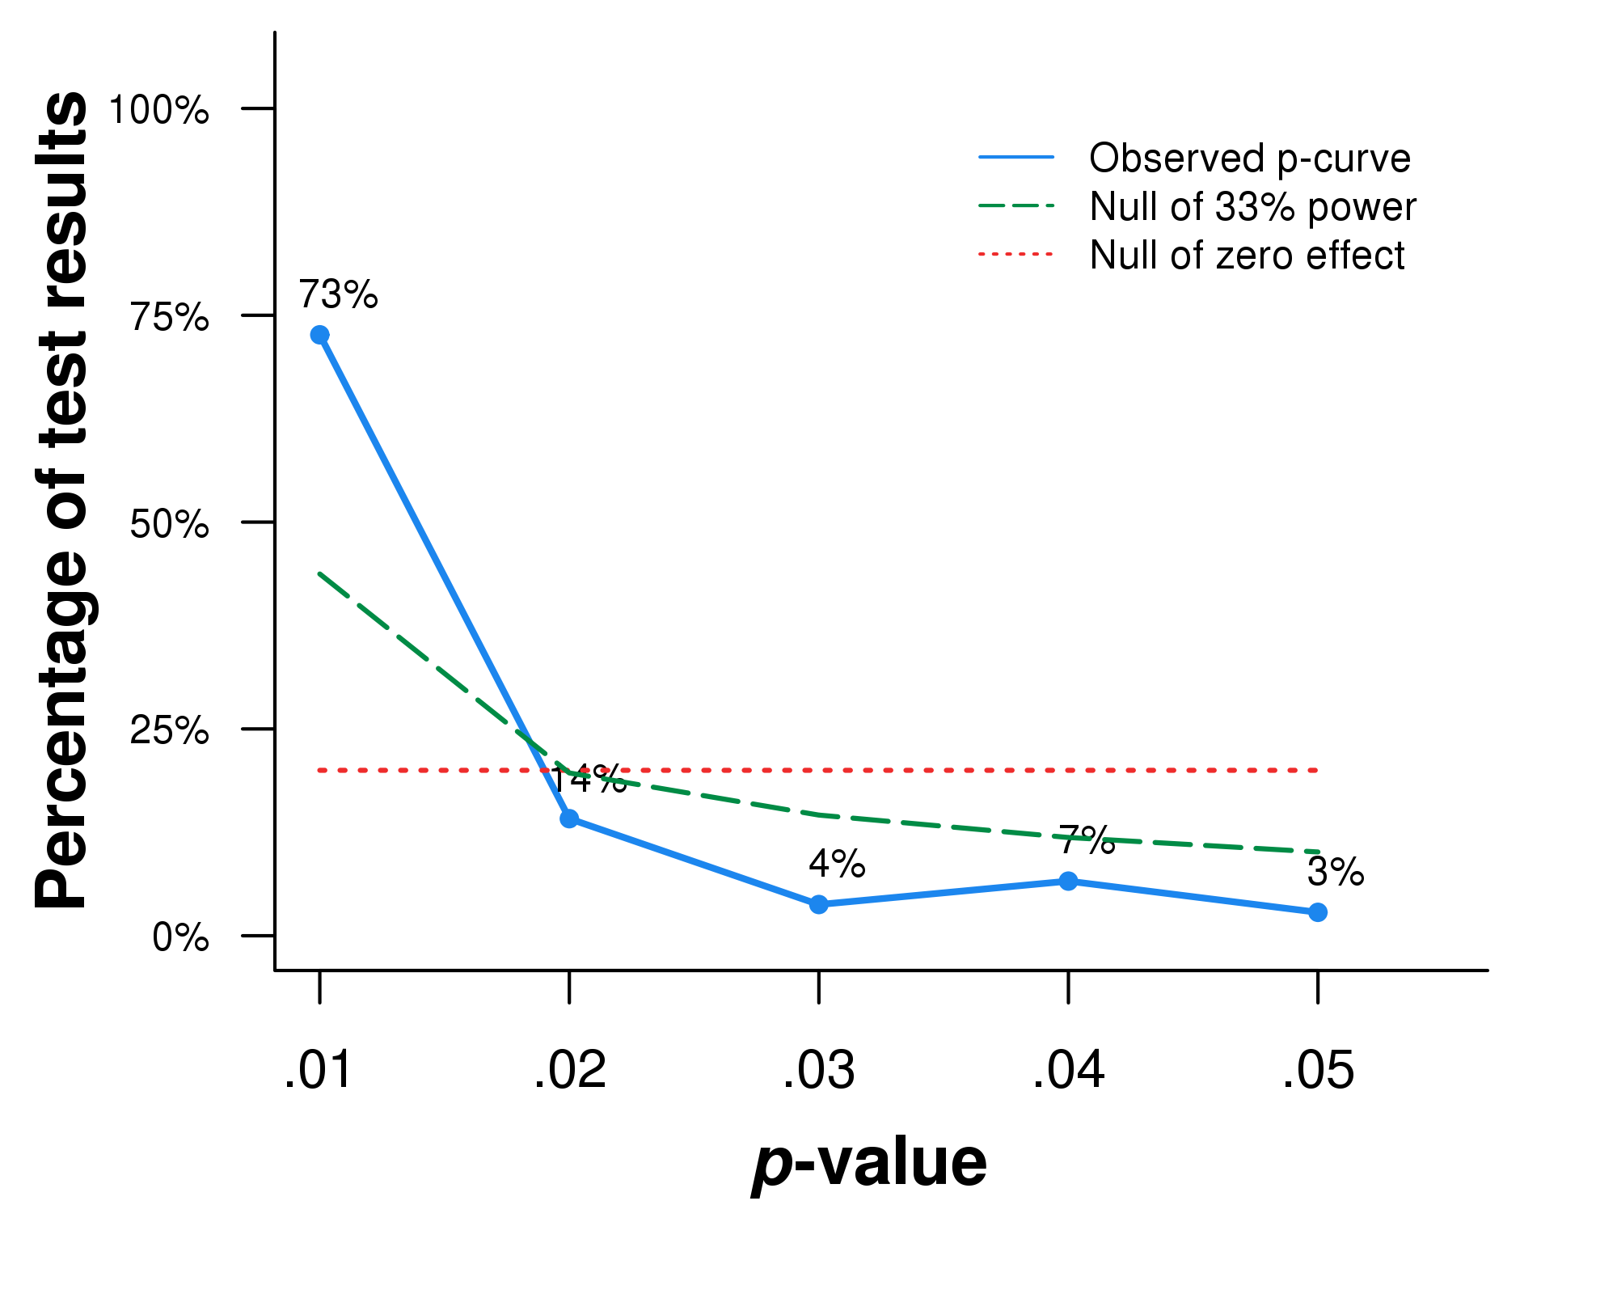

*Figure 1*. *P*-curve containing *p* values of all statistically significant effect sizes (α= 0.05). N= 106 *p* values. 73% of all the significant results have *p* values smaller or equal to 0.01, and 87% no larger than 0.02. The curve is significantly right-skewed based on both the binomial test (share of significant results p <.025; p< 0.0001) and the continuous test (Z = -23.28, *p* < .0001).

Then we conducted *p*-curve analyses for on both agentic constructs and communal constructs, respectively.

Out of the 95 effect sizes on agentic constructs, 19 of them were excluded from *p*-curve because of insignificance. The remaining 76 significant results were included in the *p*-curve.

Figure 2 displays the distribution of the *p* values of all significant results for agentic constructs, presenting a curve of *p* values that is statistically significantly right-skewed, indicating that studies on agentic constructs contain evidential value, and are not subject to publication bias or p-hacking.

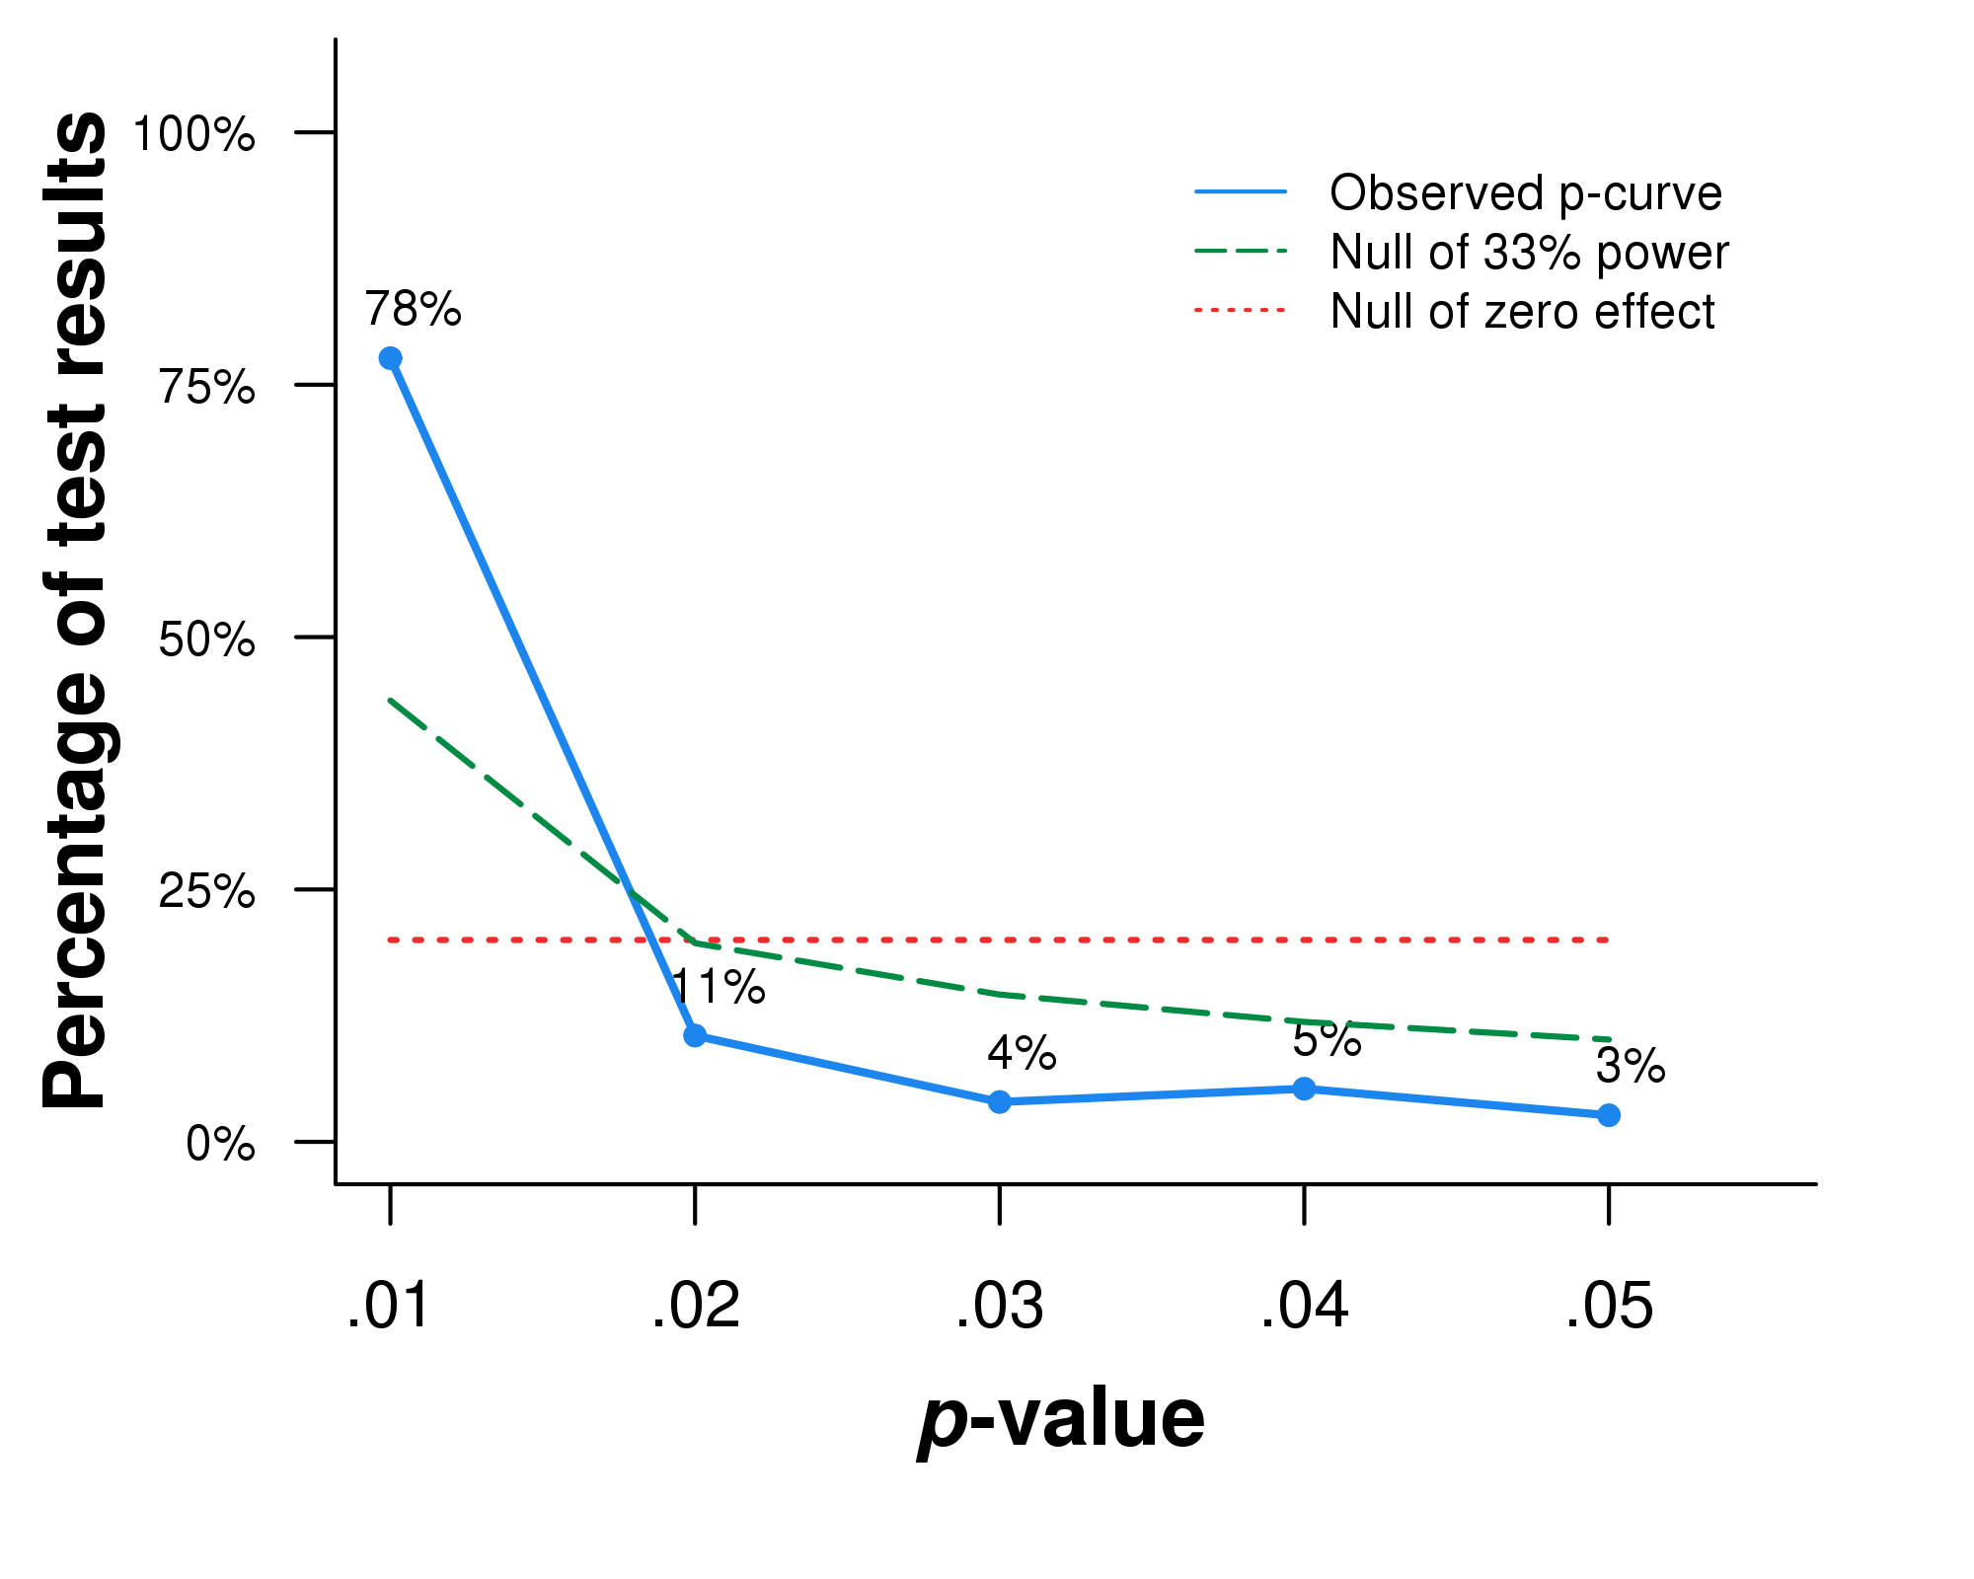

*Figure 2*. *P*-curve containing *p* values of all statistically significant effect sizes on agentic constructs (α= 0.05). N = 76 *p* values. 78% of all the significant results have *p* values smaller or equal to 0.01, and 89% no larger than 0.02. The curve is significantly right-skewed based on both the binomial test (p< 0.0001) and the continuous test (Z = 0,  *p* < .0001).

Among all the studies in our meta-analysis, there are 58 studies in total looking at the relationship between narcissism and self-enhancement on communal constructs, and the *p* values of the 19 significant results were included in the analysis.

Figure 3 demonstrated the distribution of the *p* values of all significant results for communal constructs. The curve, again, is significantly right-skewed, contradicting the speculation that the results are out of publication bias and p-hacking instead of real effects.

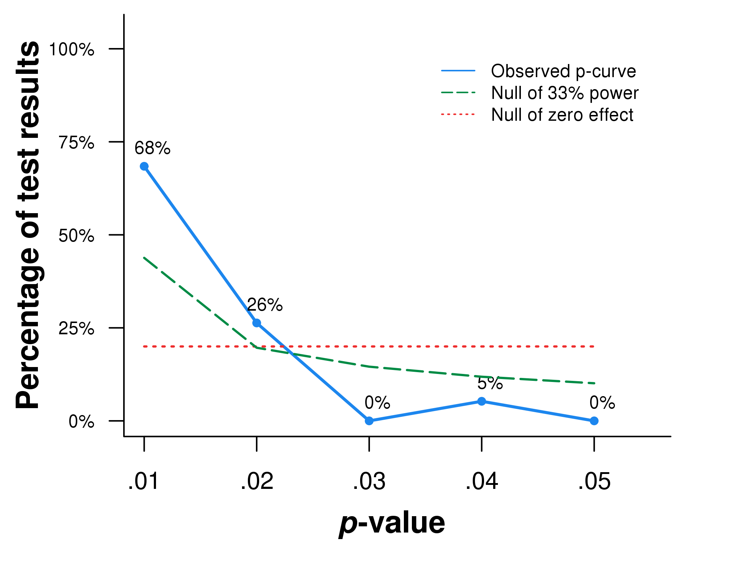

Figure 3. *P*-curve containing *p* values of all statistically significant effect sizes on agentic constructs (α= 0.05). N = 19 *p* values. 68% of all the significant results have *p* values smaller or equal to 0.01, and 94% no larger than 0.02. The curve is significantly right-skewed based on both the binomial test (p< 0.0001) and the continuous test (Z = 0, *p*<.0001).

To conclude, all 3 analyses on the distribution of *p* values of studies with statistically significant results have shown signs of publication bias or p-hacking by demonstrating significantly right-skewed *p*-curves.